**Ma’lumotlar tuzilmasi va algoritmi**

**F.I.SH. Omonbayev Jaloliddin Ravshanbek o’g’li**

**Guruh: 911-21 guruh talabasi**

**Amaliyot: 9**

**Misol: 17 .**

**Dasturlash tili: C++ CodeBlocks**

1. **Navbatda birinchi va oxirgi elementlar o’rni almashtirilsin.**

#include <bits/stdc++.h>

using namespace std;

void rev(queue<int>&x){

int sz=x.size(),mytop,mybottom;

mytop=x.front();

x.pop();

int tmp[sz-1],i=0;

while(!x.empty()){

mybottom=x.front();

tmp[i++]=mybottom;

x.pop();

}

queue<int> returnIt;

returnIt.push(mybottom);

for(i=0;i<=sz-3;i++){

returnIt.push(tmp[i]);

}

returnIt.push(mytop);

while(!returnIt.empty()){

int tt=returnIt.front();

x.push(tt);

returnIt.pop();}

}

int main() {

queue<int>x;

x.push(1);

x.push(2);

x.push(3);

x.push(4);

x.push(5);

queue<int>y=x;

cout<<"Navbat elementlari : ";

while(!y.empty()){

int tt=y.front();

cout<<tt;

y.pop();

}

rev(x);

cout<<endl<<

"Navbat birinchi va oxirgi elementlari o'rni almashtrildi : ";

while(!x.empty()){

cout<<x.front();

x.pop();

}

return 0;}

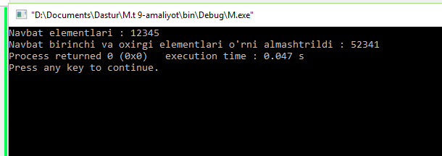

1. **Navbat birinchi elementiga teng elementlari o’chirilsin.**

#include<bits/stdc++.h>

using namespace std;

int main()

{

queue<int> q;

queue<int> q2;

int n,k;

cout <<"n= ";cin>>n;

for(int i=0;i<n;i++)

{

cin>>k;

q.push(k); }

int a=q.front();

while(!q.empty())

{

int b=q.front();

if(b!=a)

{

q2.push(b); }

q.pop(); }

while(!q2.empty())

{

cout<<q2.front()<<' ';

q2.pop(); }}

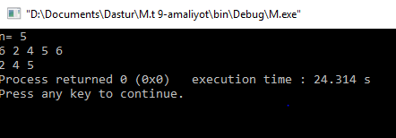

1. **Navbat o’rtasidagi element o’chirilsin.**

#include<bits/stdc++.h>

using namespace std;

void element(queue<char> &q, int n, int current=0){

if(q.empty() || current == n){

return;

}

int x = q.front();

q.pop();

element(q, n, current+1);

if(current != n/2){

q.push(x);

} }

int main(){

queue<char> qu;

qu.push('5');

qu.push('4');

qu.push('3');

qu.push('2');

qu.push('1');

element(qu, qu.size());

while(!qu.empty()){

char p=qu.front();

qu.pop();

cout << p << " "; }

return 0;}

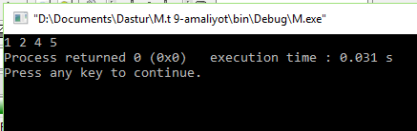

1. **Navbat juft elementlari o’chirilsin.**

#include <bits/stdc++.h>

using namespace std;

static void printQueue(queue<int> q)

{

while (!q.empty())

{

cout << q.front() << " ";

q.pop();

}

}

static void deleteEven(queue<int> q)

{

queue<int> temp;

while (!q.empty())

{

int val = q.front();

q.pop();

if (val % 2 == 1)

temp.push(val);

}

while (!temp.empty())

{

q.push(temp.front());

temp.pop();

}

printQueue(q);

}

int main()

{

queue<int> q;

q.push(20);

q.push(23);

q.push(33);

q.push(50);

q.push(11);

deleteEven(q);

return 0; }

